About 1 in 5 people develop cancer in their lifetime, approximately 1 in 9 men and 1 in 12 women die from the disease.
https://www.who.int/news/item/01-02-2024-global-cancer-burden-growing--amidst-mounting-need-for-services
A Michigan study found a 24% increase in heart attacks on the Monday after the spring switch, compared with a 21% reduction in heart attacks on the Tuesday after the fall time change.
https://openheart.bmj.com/content/1/1/e000019
https://nypost.com/2019/06/11/this-many-americans-still-sleep-with-childhood-comfort-objects/
Dragonflies have the highest observed hunting success of any animal, with success rates as high as 97%. They are also opportunistic and pursue a variety of prey.
https://en.wikipedia.org/wiki/Hunting_success#:~:text=Dragonflies%20have%20the%20highest%20observed,pursue%20a%20variety%20of%20prey.
Consumers are 1.5x more likely to be motivated by an online review than by a discount offer
Around 4 in 5 consumers have read a fake review in the last year
https://explodingtopics.com/blog/online-review-stats
79.48% of all statistics are made up on the spot.
https://math.libretexts.org/Courses/Cerritos_College/Mathematics_for_Technology/03%3A_Module_3-_Probability_and_Statistics/3.09%3A_What_is_Statistics
Genghis Khan Killed Enough People To Cool The Planet
https://www.iflscience.com/genghis-khan-killed-enough-people-to-cool-the-planet-71583
In other words, the genetic line showed that about 8 percent of men in the region of the former Mongol empire, and therefore about one in 200 worldwide, share one single male ancestor – and based on a combination of logic, statistics, and common sense, that ancestor was almost certainly Genghis Khan.
https://www.iflscience.com/fact-check-are-one-in-200-people-descended-from-genghis-khan-65357?utm_source=TrendMD&utm_medium=cpc&utm_campaign=IFLScience_TrendMD_0
https://www.pfizer.com/news/articles/how_genetically_related_are_we_to_bananas
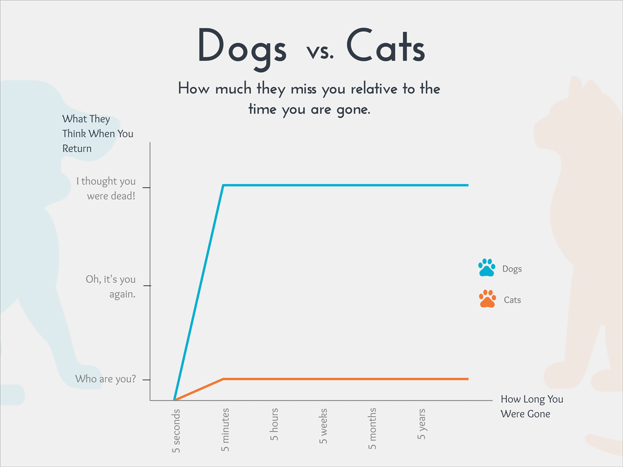
The global rate for washing hands after using the toilet is under 20 percent.
https://www.wateraid.org/uk/media/globally-4-out-of-5-people-do-not-wash-hands-after-going-to-the-toilet
https://www.cdc.gov/museum/pdf/cdcm-pha-stem-hand-hygiene-lesson.pdf
The average person could fill as many as 23 2-liter bottles with the amount of saliva they produce in a month.
https://www.ncbi.nlm.nih.gov/pmc/articles/PMC5052503/
